Universal Health Insurance Plan

Version 1.0 ● 20 NOV 2020

Contents

Section 1. Project Overview 1

1.1 Project Description 1

1.2 Project Scope 1

1.3 Assumptions 2

1.4 Constraints 2

Section 2. Project Start-Up 3

2.1 Project Life Cycle 3

2.2 Methods, Tools, and Techniques 3

2.3 Estimation Methods and Estimates 3

2.4 Schedule Allocation 4

2.5 Resource Allocation 4

2.6 Budget Allocation 5

Section 3. Risk Management 6

# Section 1. Project Overview

## Project Description

What is universal health insurance?

It is a mandatory social solidarity system that covers all citizens, and the state guarantees those who are unable. As it separates funding from the provision of health services, and the flexibility of the service package provided, which is not less than the services currently provided. It provides high-quality health services, and 30% of the population is classified as "unable" and will be covered by the state. The comprehensive social insurance to be applied covers all groups of society as a whole, meaning that the whole society will be subject to its insurance umbrella in return for payment of contributions. Within it the unit of coverage is the family and not the individual, as in the current system. Provides access to and support for the insured's freedom to choose between any of the health service providers, whether in the governmental or non-governmental sectors, included in the comprehensive health insurance network. It is subject to a uniform law that avoids the defects of existing laws. It applies to the fields of insurance health services and does not apply to public and preventive health services or health services for covering natural disasters, epidemics and similar services that all state agencies are bound by. Through it, the mechanism for pricing medical services is determined in a fair manner that meets the quality standard, through a committee represented by the private, public and independent sectors. The percentage of citizens ’participation in the current law ranges between 1% of the employee's insurance wage, and 3% of the employer per month, and in the new law it will be the same, but on the total income, in addition to the family head paying the contributions of the person responsible for them, namely: the non-working wife At a rate of 2.5%, and the rest of the family at a rate of 0.75% for each person, and the state treasury pays the contribution of those who are unable. The subscriber to the new health insurance pays a nominal percentage, at the time of performing the x-rays, up to 10% and 20% for analyzes, to control the provision of the service, while the surgeries are performed without any contributions except for the payment of the basic subscription.

## 1.2 Project Scope

*Our project serves all segments of society, whether able or not, by providing all medical services that:*

*1. Contributions include the family as a whole, not just the individual.*

*2. The subscribers provide health care, which includes checks and examinations, some surgeries and other high-quality analyzes and rays, in addition to the percentage of discounts on them.*

*3. It allows the subscriber to choose a hospital that is close to him or of high quality and that belongs to that system at reduced costs.*

*4. It provides patients with chronic diseases monthly medicines and dispensing medicines free of charge*

*5. Keep patient data confidential.*

*6. Motivates the most efficient doctors to increase their salaries.*

*7. It did not include governmental and insurance hospitals only, but also hospitals affiliated with higher education and private hospitals.*

*8. Provide every citizen with his own medical record, which is served in an organized periodical way.*

*9. Provide a database that includes patients' data and the latest updates on it on a regular basis, which can be accessed through any hospital affiliated with the system.*

|  |
| --- |
| **Project Includes** |
| Citizens' participation in universal health insurance. |
| Every patient has its medical record and every family has its family doctor. |
| The treatment is free of charge, and there are discounts on surgeries and examinations. |

|  |
| --- |
| **Project Excludes** |
| The imposition of a government hospital and the lack of eligibility to choose the appropriate hospital for treatment. |
| Employee participation and non-tolerance for all segments of society. |

## 1.3 Assumptions

*The project includes assumptions that:*

*The head of the family goes to the comprehensive health insurance unit and gives the administrator all the data about the family to make medical record for the family with a unique number, and all family members make a comprehensive examination that includes a ‘primary examination, analysis and radiation’ and add the medical history of all family member, then add of all that to the family medical record, pay contributions, and assign The family doctor for each family and he is responsible for the therapeutic trip for that family and adding the data to the family file, and when the visit continues at any time, the subscriber must give the administrator the number of the medical record to administrator and choose the department that he wants to examine him and make an examination then takes Treatment, and adding that visit to the family file. The patient can choose the appropriate hospital for him to do surgery or other tests.*

|  |
| --- |
| **Assumptions** |
| Save medical history of patient. |
| Treatment of the unable is at the expense of the state. |
| Increase doctors' salary. |
| Provide medicines for chronic diseases all time. |

## 1.4 Constraints

|  |
| --- |
| **Constraints** |
| We must finish 25% of the project work within 2 weeks. |
| We must work within available resources. |
| Distribution of team must be effort.. |
| Provides all citizens in Egypt Arabic Republic. |
| Budget must = 50,000$.  Schedule must take 2 weeks. |
| System must be rapid. |
| Time of one task must be convenient to its size. |

# Section 2. Project Start-Up

## 2.1 Project Life Cycle

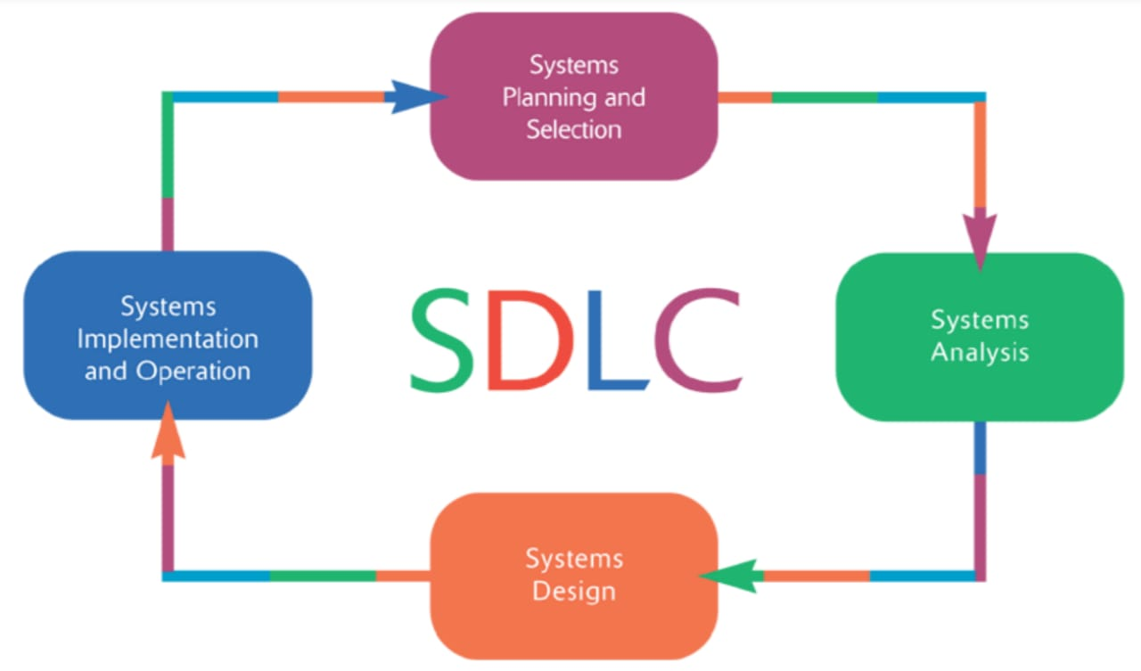

## 2.2 Methods, Tools, and Techniques

We use some technology and programming language to make this project like:

- Use database by using local server wampserver3.1.3.

- Java by using Netbeans.

- Desktop Application by using Netbeans.

- Gant Chart Microsoft office management project.

- Creately SoftDigram.

- We use software engineering to plan the project

## 2.3 Estimation Methods and Estimates

| **Estimation Methods and Estimates** | |
| --- | --- |
| Description | Most - likely - best - worst |
| Effort in person-months or person-hours | Hours |
| Schedule in calendar weeks | Weeks (1) …….planning  weeks(2)… ….....collection requirements  weeks( 3)….Analysis  weeks(4)….Design  weeks(5)….Develop  weeks(6)….Maintenance and testing  weeks(7)……Deliver and install |
| Budget in dollars | 50,000$ |
| Level of Uncertainty | 9 % |

## 2.4 Schedule Allocation

|  |  |
| --- | --- |
| **Major Milestone/Deliverable** | **Planned Completion Date** |
| Planning | *8/11/2020* |
| Collection requirements | *16/11/2020* |
| Analysis | *24/11/2020* |
| Design | *2/12/2020* |
| Implement | *10/12/2020* |
| Maintenance | *18/12/2020* |
| Deliver and install | *24/12/2020* |

## 2.5 Resource Allocation

|  |  |  |  |
| --- | --- | --- | --- |
| **Resource** | **Total** | **Skill Set Requirements** | **Timeframe** |
| Analysis | 4 | Communication Skills. Technical Skills. Analytical Skills. Decision-Making Skills. | From 17/11  To 24/11 |
| Design | 3 | The skills required in design good user interface programming. | From 25/11  To 2/12 |
| Implementation | 6 | Good at Java and solve problems in it. | From 3/12  To 10/12 |
| Tester | 4 | know different testing techniques and usage of tools | From 11/12  T0 18/12 |
| Computers | 6 | …………………………. | …………………. |
| Server | 1 | Technical Understanding, Telecommunications Technologies. | From 18/12  To 24/12 |
| Bar code system | 2 | ……………………………. | ………………….. |

## 2.6 Budget Allocation

|  |  |  |
| --- | --- | --- |
| **Key Budget Category** | **Budget Amount** | **Time Period** |
| Recourses | 18000$ | ----- |
| Developer | 48000$ | 1 week |
| Database administrator database oracle | 45000$ | 1 week |
| Designer | 5000$ | 1 week |
| Analyst | 17000$ | 1 week |

# Section 3. Risk Management

|  |  |  |  |
| --- | --- | --- | --- |
| **Risk Description** | **Probability** | **Impact** | **Strategy** |
| ***Cost Estimates*** | **low** | **high** |  |
| ***Time Estimates*** | **high** | **high** | **We divided the work on all the members of the project and work together and discuss ideas together so that we deliver on time.** |
| ***Team Size*** | **low** | **low** | **In the case of the project, the number of project personnel was appropriate and if there was a shortage of an individual, the remainder would compensate for this shortage and work together.** |
| ***Team Members Unknowledgeable of Business*** | **high** | **Very high** | **We cooperated and assisted each other so that all of team knew about the project and we did research to solve any problem we face and search for the information required in this project.** |
| ***Narrow Knowledge Level of Users*** | **low** | **high** | **We have trained the user on how to use the system and deal with it.** |